**CMSC203 Assignment 0**

Class: CMSC203 CRN 21456

 Program: Assignment 0

Instructor: Dr. Ahmed Tarek

 Summary of Description: This is the setup of the programming environment.

 Due Date: 09/13/2021

 Integrity Pledge: I pledge that I have completed the programming assignment independently.

 I have not copied the code from a student or any source.

**Complete the following five parts of Assignment 0:**

**Part1: Setup GitHub:** Provide the screen shots of your GitHub account with Assignment 0 file is uploaded here:

**Part 2 -Install JDK, Test java Application from Command Line**

Provide the screen shots from Step 1 and 2 here:

**Part 3 - Install Eclipse, Test Eclipse Java Application**

Provide the screen shots from Step 1 and 2 here:

**Part 4 - Install, Setup, Test Junit Program.**

Provide the screen shots showing:

* 1. Eclipse with working JUnit Test example
  2. Project screenshot
  3. Running example screenshot

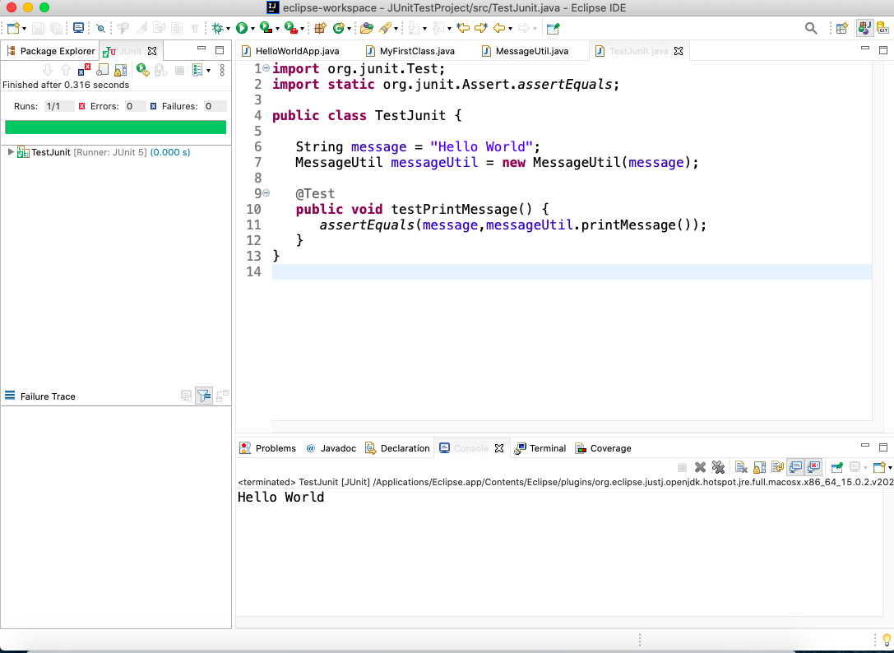

**Part 5 - Install, Setup, and Test JavaFX Application.**

Provide the screen shots showing:

1. JavaFX Project screenshot
2. Running example screenshot
3. Java Source Code File

**Lessons Learned** <Provide answers to the questions listed below>**:**

Write about your Learning Experience, highlighting your lessons learned and learning experience from working on this assignment.

What have you learned?

I learned how to setup JavaFX properly and I also learned how to use the Junit test runner properly.

What did you struggle with?

The setup for JavaFX was difficult. My security settings were blocking the path to the JavaFX SDK.

What parts of this assignment were you successful with, and what parts (if any) were you not successful with?

I was able to complete all the tasks.

Provide any additional resources/links/videos you used to while working on this assignment.

**Check List:** <Provide answers to the column Y/N or N/A >**:**

|  |  |  |  |
| --- | --- | --- | --- |
| **#** |  | **Y/N** | **Comments** |
|  | **Assignment files:** |  |  |
|  | * FirstInitialLastName_Assignment0.docx/pdf | **Yes or No** |  |
|  | * Source java files | **Yes or No** |  |
|  | **Program compiles** | **Yes or No** |  |
|  | **Program runs with desired outputs related to a Test Plan** | **Yes or No** |  |
|  | **Documentation file: Screenshots of** |  |  |
|  | * Part1: Setup GitHub | **Yes or No** |  |
|  | * Part 2 -Install JDK, Test java Application from Command Line | **Yes or No** |  |
|  | * Part 3 - Install Eclipse, Test Eclipse Java Application | **Yes or No or N/A** |  |
|  | * Part 4 - Install, Setup, Test Junit Program | **Yes or No or N/A** |  |
|  | * Part 5 - Install, Setup, and Test JavaFX Application. | **Yes or No or N/A** |  |
|  | * Lessons Learned | **Yes or No** |  |
|  | * Checklist is completed and included in the Documentation | **Yes or No** |  |